Practical 4: JavaScript DOM Manipulation, Event Handling, and UI Interactivity
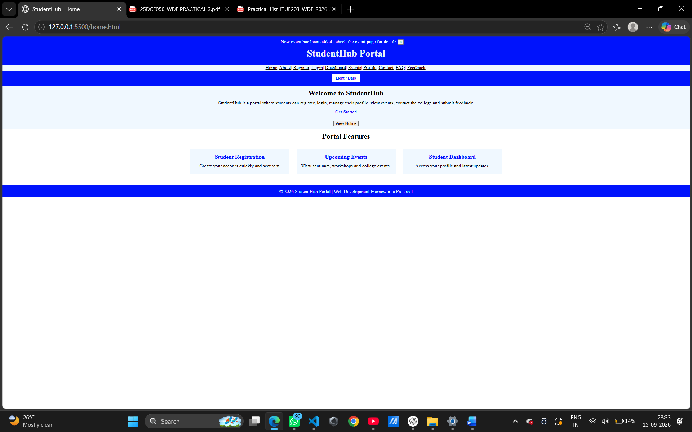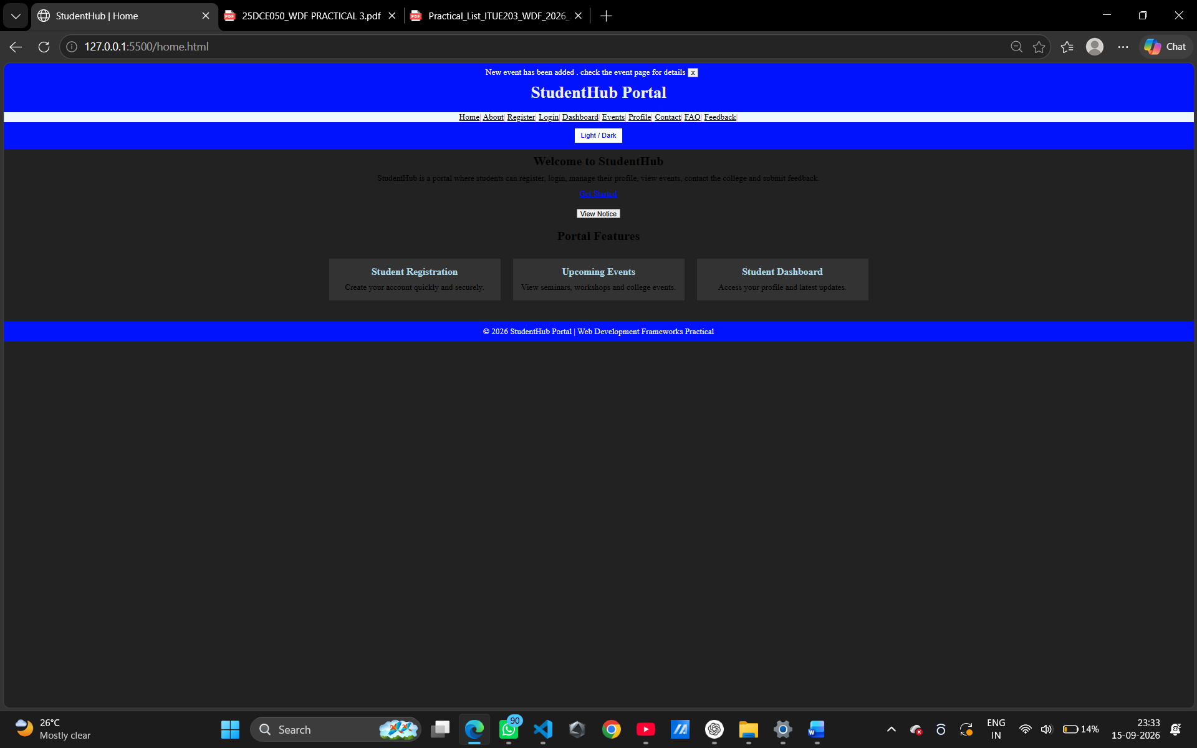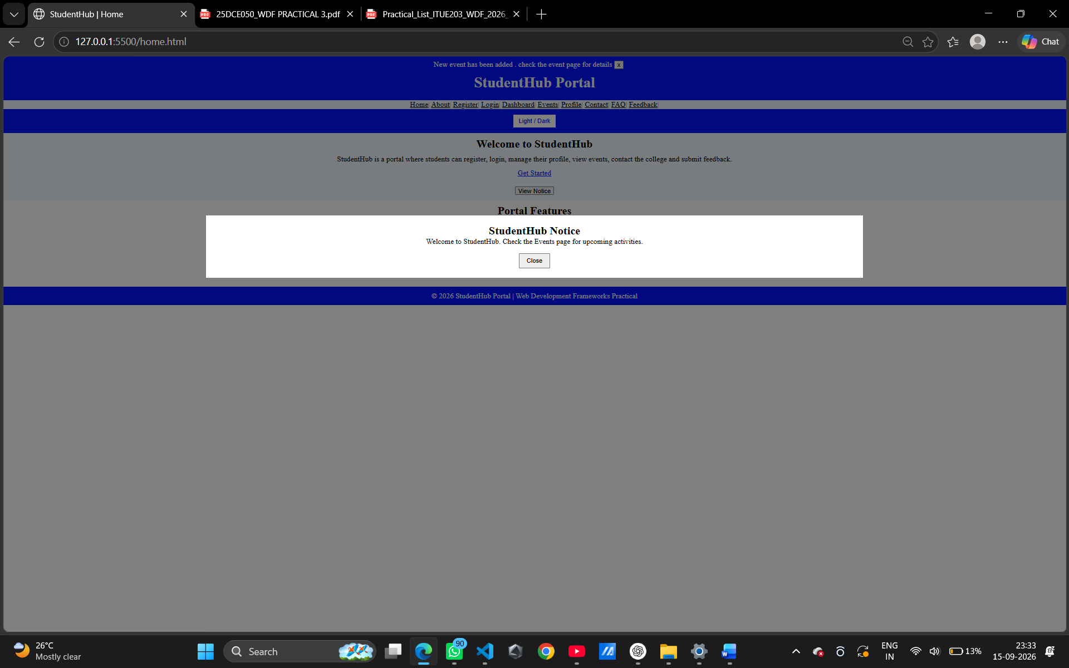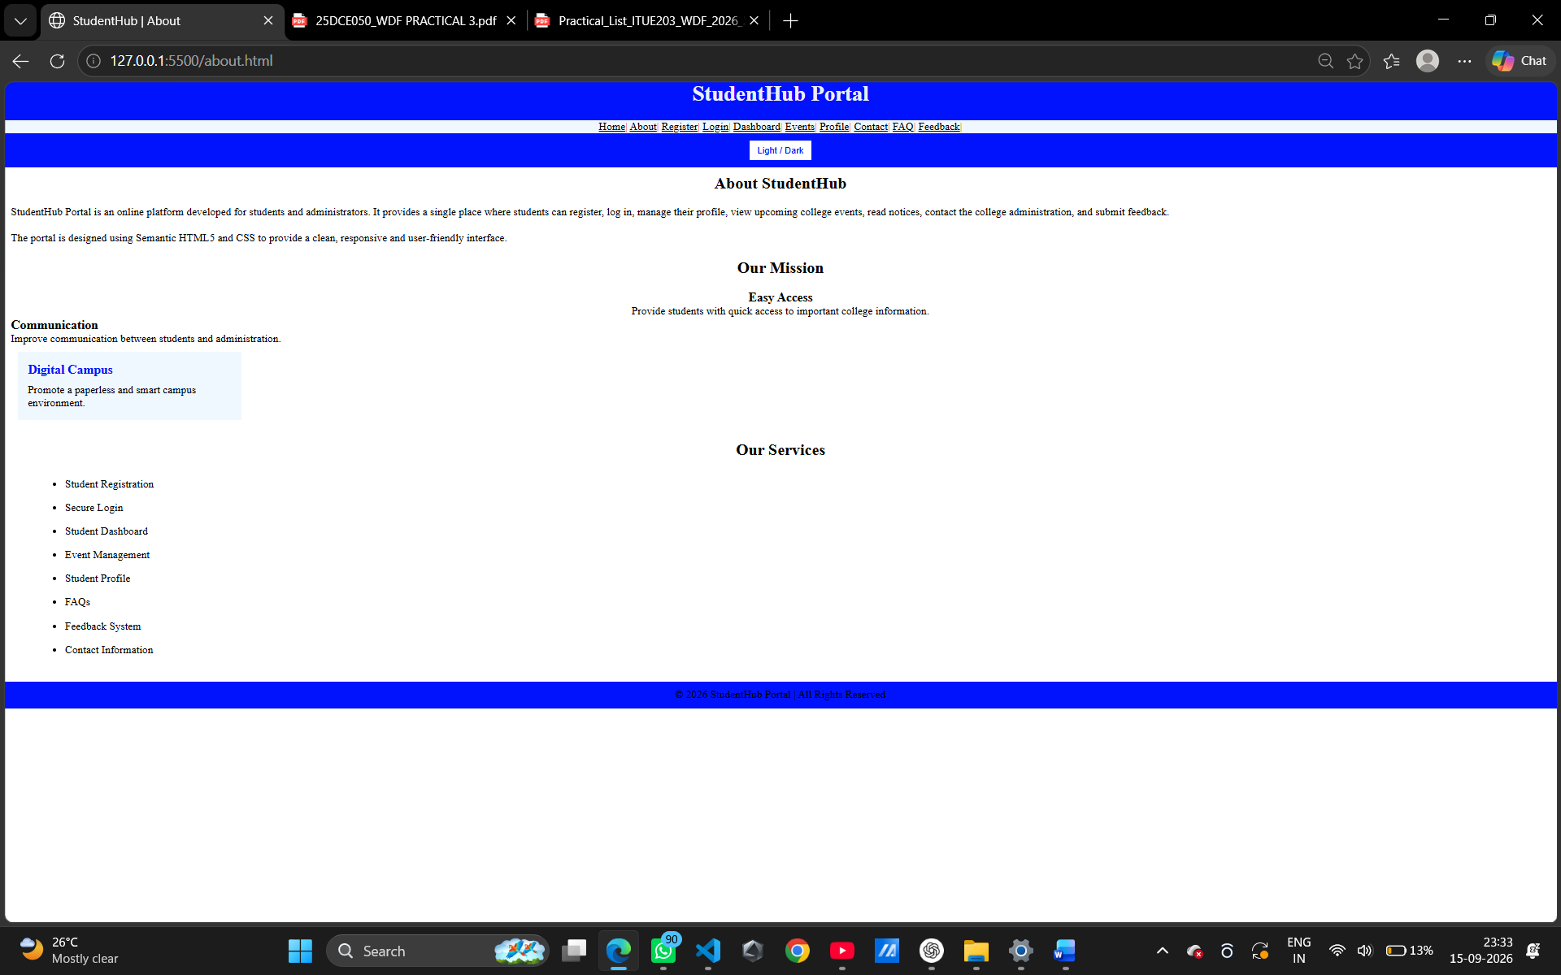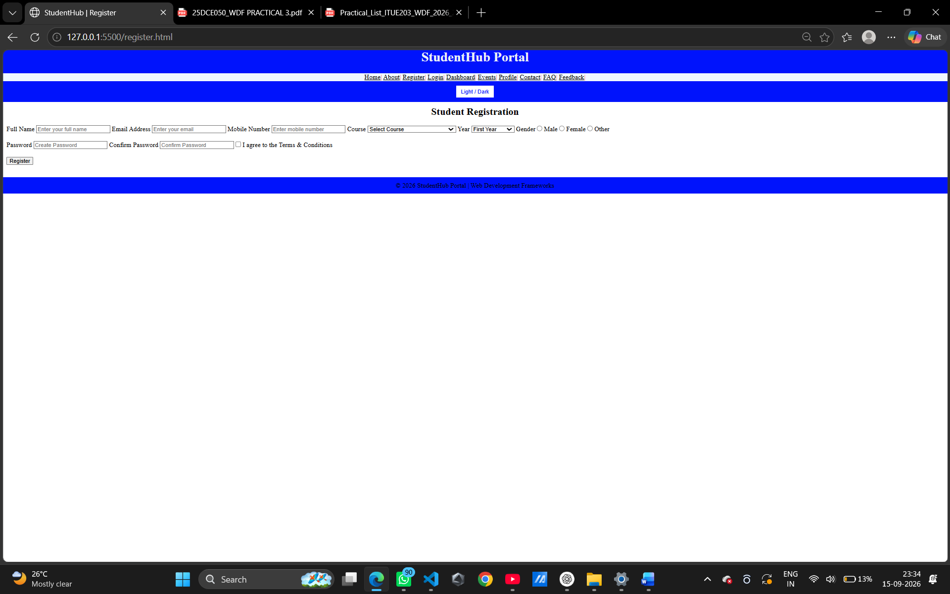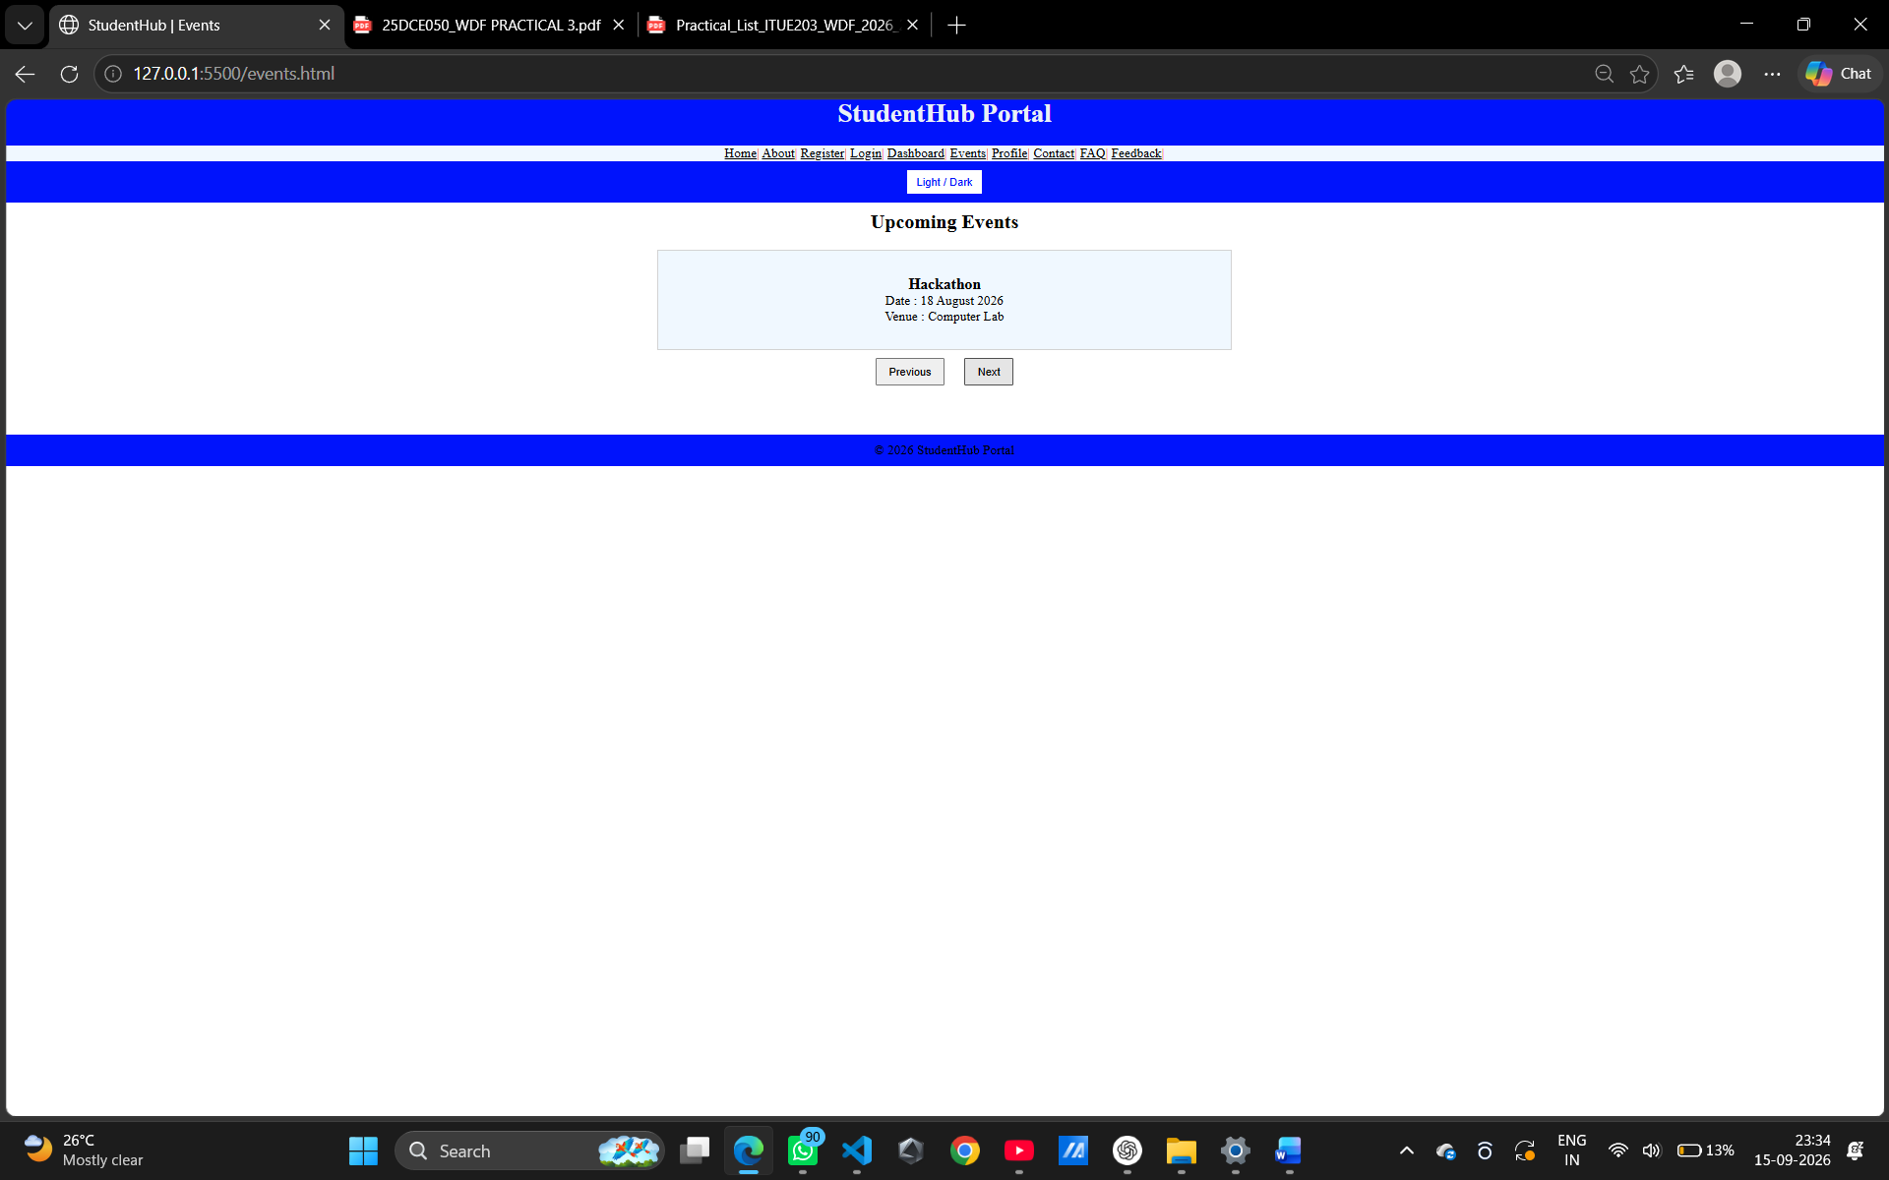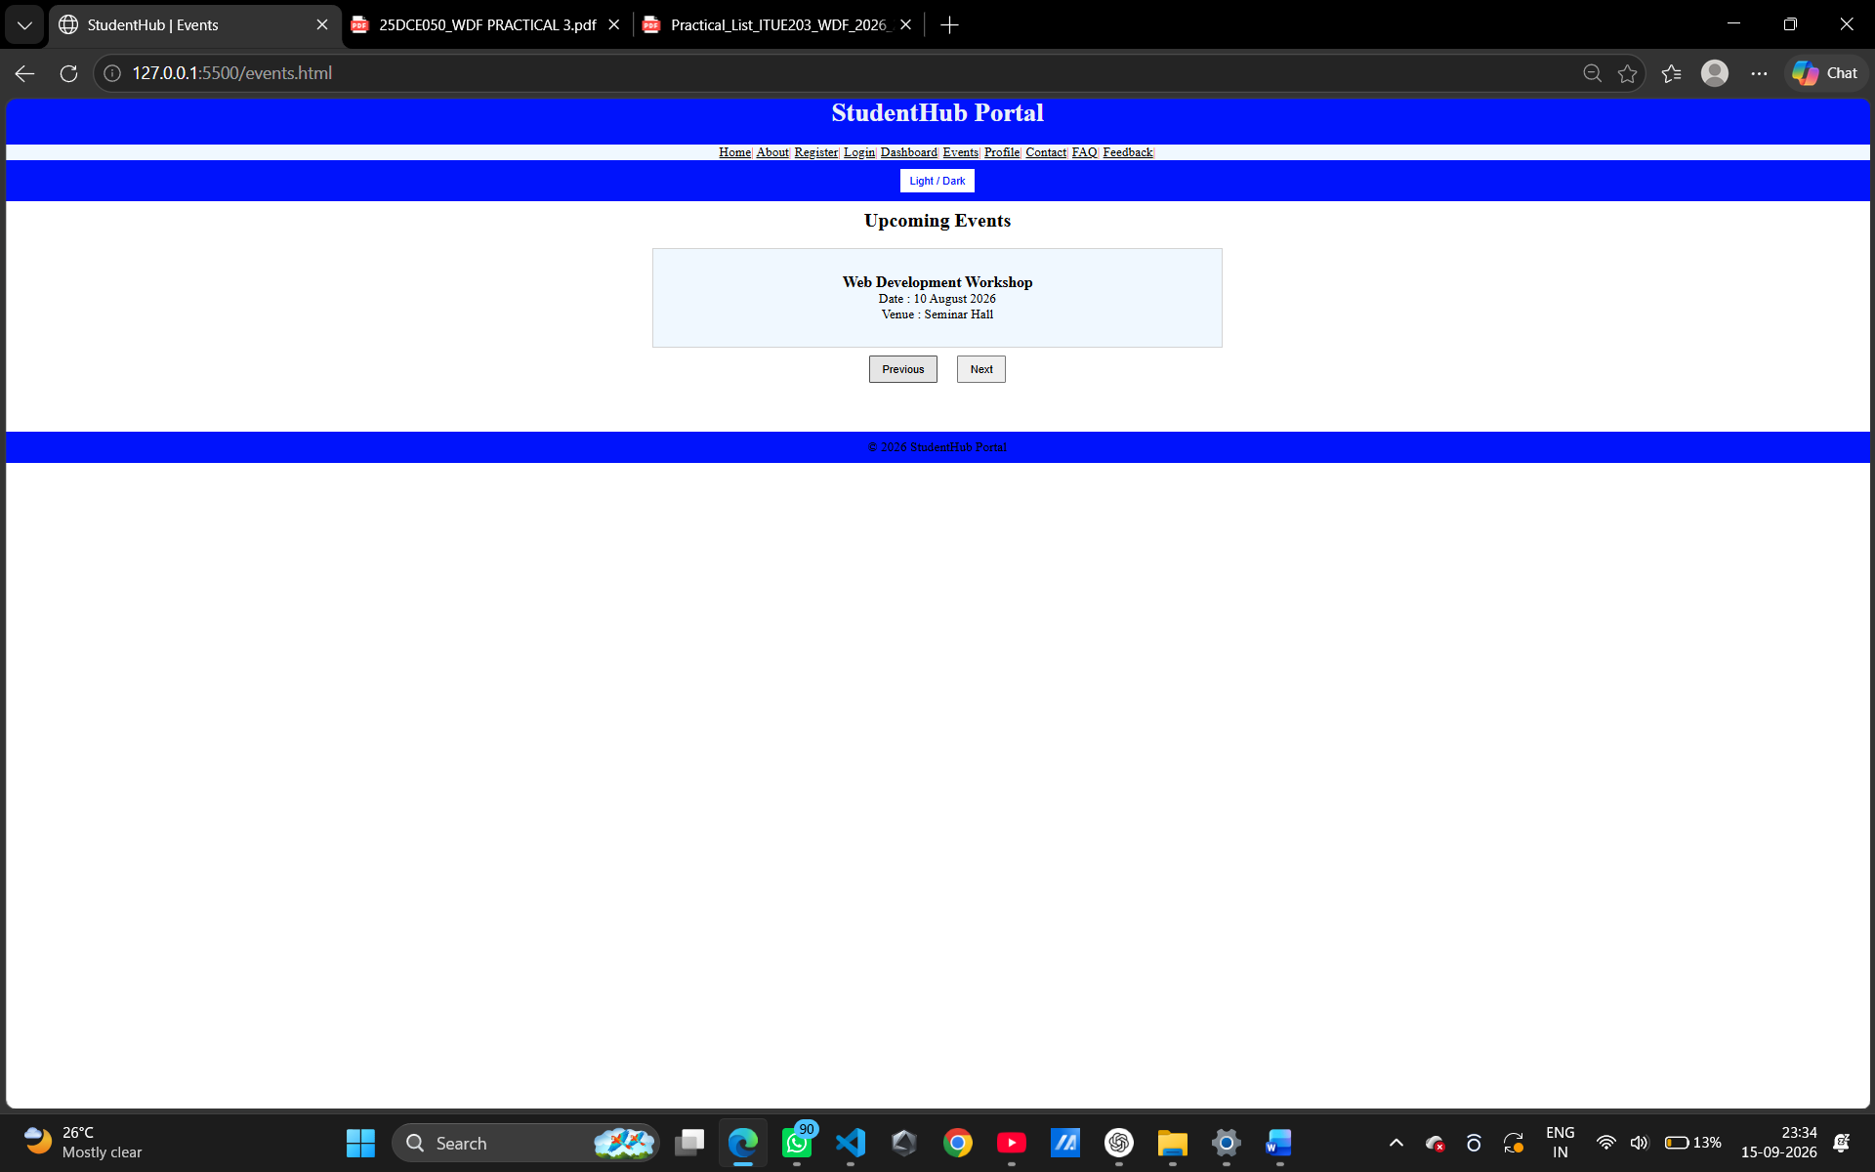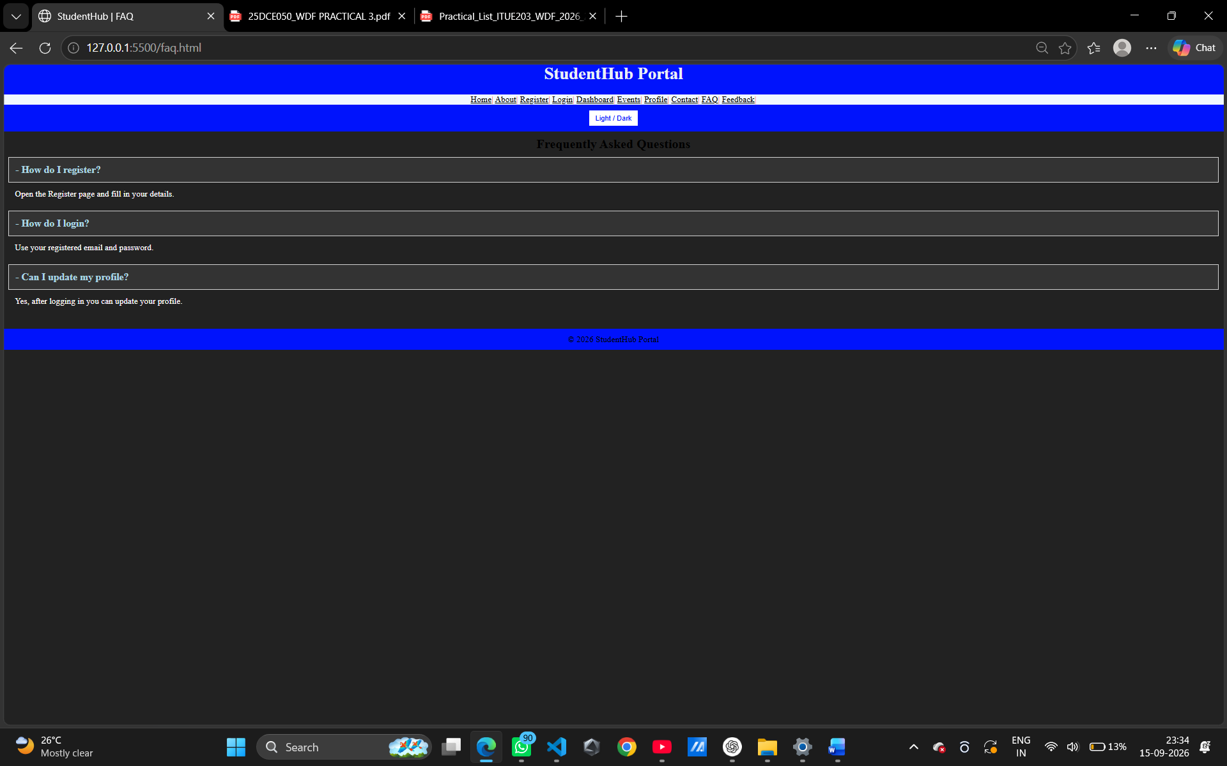
LARNNING OUTCOME : I learned how to use JavaScript to make web pages interactive. I learned how to manipulate HTML elements using the DOM, handle user events, create interactive components, and use localStorage to save the Light/Dark Mode preference.

